Book Monitoring System

“Project Proposal”



By:

Raúl Y. Mora-Colón
Arnaldo A. Oliver-Román
Antonio G. Rodríguez-Jiménez
Emanuel González-González

For:
José F. Vega-Riveros
Nayda G. Santiago-Santiago
Course ICOM 5047
Date: September 10, 2008
Abstract
As society evolves there is a need for information and knowledge which throughout the past years have been placed in books. There are other ways of passing and storing information, but for hundreds of years books have existed and they can be mainly accessed or read by the public in libraries around the world. The conflict is generated in the reality that society is moving faster every day. People do not want to go to a library to make lines, waiting for a librarian to get a book. Due to the concurrent need of fastening processes to comply with the busy lifestyle we have, there’s a need for a more efficient and faster service system in libraries at the moment of getting books out and into it. What is proposed is a system to accelerate this process, a self service book check-out and check-in system. Instead of having to remember a library member number, or giving a regular ID to the librarian, the user will only need an ID card which uses the innovative RFID technology. This technology has been proven to be efficient for inventories, access control and a large amount of people basic daily operations. The user only needs to go to the station with his/her id, place it in the system, place the requested books in the station, and accept the order and he/she is ready to go. To return the book just deposits the book in the station and the book is returned. No unnecessary lines or additional waiting required.

Table of Contents
1. Executive Summary 5
1.1. Introduction 5
1.2. Expected profitability and competitive impact 6
2. Project Antecedents 7
2.1. Relationship to other projects 7
2.2. Project importance and advantages 7
3. Proposed Solution 9
3.1. Objectives 9
3.2. Scope 9
4. General approach 10
4.1. Team Organization 10
4.2. Personnel 10
4.3. Managerial Approaches 11
4.4. Special Skills 11
5. Specifications 13
5.1. Hardware Specifications 13
5.2. Software Specifications 17
6. Contractual aspects 20
6.1. Agreements with clients and third parties 20
6.2. Milestones 20
7. Schedules 21
7.1. WBS 21
7.2. Outline of schedules (gannt chart) 22
8. Resource requirements 23
8.1. Estimated project expenses 23
9. Assessment methods 25
9.1. Assessment 25
9.2. Procedures for monitoring, collecting and storing data 25
9.3. Quality Control 25
10. Potential Problems 26
10.1. Risk assessment 26
10.2. Risk plans 26
11. Impacts 27
11.1. Environmental 27
11.2. Legal 27
11.3. Social 28
11.4. Market overview 28
References 30

Executive Summary

Introduction
Currently, there are some libraries that use an old tedious process to carry out the leasing of books. Usually, the user creates a new account and waits for the librarian to service him/her. This service can be delayed due to a queue of people waiting for the librarian, the librarian is busy doing some other task or simply distracted. After waiting, the user starts the process by providing his/her name, student ID and library account number or enrollment copy. Then, the librarian searches find the barcode and scan the book(s). This long process can take a lot of time and money, which is why a new system must be implemented to make this process automatic and efficient.
Instead of waiting and go through this process, the customer would self check-out his/her books. Using the RFID technology, the customer would go to a computer station to start a three step process: Scan his/her card, place the book in the scanner and confirm the lease order. Then the customer can take the book home. Once the customer finishes using the book and desires to turn it back, he/she would use a self check-in station where he would just drop-in the book.
The solution will include the following deliverables:
- Web Application for remote access to library services
  - User accounts for administrators, employees and customers
  - Search library catalog
- Database to retain information of users and books, and transactional data, such as the leased books, bills and reservations
- Prototype of a check-out / check-in station

The Book Monitoring System (BMS) will replace the old search of some libraries where they use the customer name, a regular identification or a member number to search for a record and/or the barcode system used in other libraries.
Besides the check-out station, the system will have a check-in station. This station will use a one step process: Place the book in a delivery window or box. A scanner will be placed in the station, so the check-in process can also make use of the RFID technology to make the process automatic. The customer and library employees will have the option to access library services by means of a Web Application. These features helps librarians by reducing their time spent in the leasing process, even though the employee will still be able to manage customer accounts. To protect the book information integrity stored in the database, some access constraints will be established. Only administrators will be able to modify information about the books, while the employees will be able to only see it. This protects against unwanted changes and corrupt book information.
Milestones of our system:
- Project Definition
  - Project Proposal and Presentation - September 10, 2008
- Individual system implementation
  - Progress Report and Presentation - October 29, 2008
- System integration and completion
  - Final Report Due - December 1, 2008
  - Final Presentation - Date selected by registrar’s office

The team for the development of this system is composed of four members Antonio G. Rodríguez, Arnaldo A. Oliver, Emanuel González and Raúl Y. Mora. For the development of the Book Monitoring System we require a budget of $54,630.84, including human resources, equipment, indirect costs and overhead costs. The project has a risk’s mitigation, monitoring and management plan for high and minor impact risks.

Expected profitability and competitive impact
In the Puerto Rican market, this product will be the second of its kind. One difference will be that the system has its approach on the needs of libraries in universities. This system offers to improve the quality of the service that is provided to the users of the library of the University of Puerto Rico, Mayagüez Campus (UPRM). Even though the system is aimed for the UPRM library, the system will be flexible enough to be implemented in different libraries. The additional functionality we offer is a web page, in which the customer can view his borrowed books, extend its return date, modify specific account information and report a lost ID. Compared with the system currently used in most libraries, this system is more advanced, requiring minimum interaction with employees. Commonly, libraries have to search for their customers using their names, member numbers, or identifications, but the system makes this easier and faster with the RFID technology. Systems all over the world are currently being redesigned to use this technology, which opens market opportunities.
Having seventy eight towns in Puerto Rico, we have found that there is at least one public library in each town, plus libraries in schools and universities and even some companies, so there are hundreds of possible customers for the product in Puerto Rico. Changing the project’s audience to United States this number can be transformed into thousands of customers which can use this product.

Project Antecedents

Relationship to other projects
Currently, no members of the team have worked in a project related or similar to this project. A member of a previous project called Smart Shopping System, which used RFID technology, is one of the project’s consultants, because of his experience with RFID’s and related systems. The similarity of between systems is that both systems use the same RFID technology, using passive tags and the anti-collision feature.
The library of UPRM, is a limited system that uses a barcode system, instead of a RFID solution, such as BMS. This system is inspired in the needs for automated and faster services that technology can provide to improve the book check-out and check-in system.

Project importance and advantages
In the past the bar code system was the most efficient system in the inventory related market, including libraries, but it has been proven that RFID technology is more advanced and effective.
Barcodes vs. RFID
Barcodes | RFID
Can be erased, covered or is unreadable over use | Stores code internally, and has a life of more than twenty years
Need to be directly scanned in order to be recognized | Can be scanned at long range; its position is not relevant
Need to be read sequentially | technology allows for multiple tags to be read simultaneously
Contains information internally which makes it very difficult to falsify | RFID tags contains information internally which makes it very difficult to falsify
Table 1: Barcodes vs. RFID
Additionally RFID capabilities can be used for other purposes, for example placing RFID scanners in doors can provide information of the location of the RFID tag in a building, which allows for future expansions of the system that barcodes does not allows.
There are two types of tags that use RFID: Active, and Passive. Judging from the advantages and disadvantages (summarized in the table below), the best suitable type for BMS are the Active RFID tags.
 | Passive | Active
Read Range | Up to about 25 feet | Up to 300 feet or more
Power | No power source | Battery powered
Tag Life | Up to 10 years depending upon the environment the tag is in 3 | 8 years depending upon the tag broadcast rate
Tag Costs | $.10-4.00 depending upon quantity, durability, and form | $5-50 depending upon quantity, options (motion sensor, tamper detection, temperature sensor), and form-factor
Ideal Use | For inventorying assets using handheld RFID readers (daily, weekly, monthly quarterly, annually) | For use with fixed RFID readers to perform real-time asset monitoring at choke-points or within zones
Readers | Typically lower cost | Typically higher cost
Table 2: Passive vs. Active
Of course this system provides a great improvement compared with old ways of getting books that do not even use barcodes, which just search for names or ID numbers. With BMS, less pressure is put in librarians, and customers can get books faster, which makes books a better option for busy citizens.
As there is a need for technology, speed and efficiency in society, this system offers these capabilities to be adapted to any library. Also, a similar system with some modifications can be used in books stores, so the system can have extended capabilities for future expansion and to cover other needs of the customers.

Proposed Solution

Objectives
- To deliver a progress report for October 29, 2008
- To deliver a final report for December 1, 2008
- To deliver a complete prototype of the system for December 1, 2008 with the functionality specified in the Scope section

Scope
The purpose of this project is to develop a prototype of a Book Monitoring System that does not exceed a cost of $54,630.84 for November 26, 2008. This system is composed of the following deliverables:
- User interface for administrator
The administrator of the system can manage the system including book and user viewer, addition, modification and removal of the system.
- User interface for employee or librarian
The employee can create, modify and view customer accounts and view books information.
- User interface for customer (book user)
The user of the system can edit his/her profile, renew and reserve books, view the status of his currently borrowed books, and report a stolen card.
- Database to retain information of users and books
The database will contain all the information of the books and users and will only be fully manageable by the administrator. All the interfaces mentioned above will have access to the database.
- Prototype of a check-out / check-in station for the library
This prototype, referred to as the station, will consist of a computer connected to the hardware of the system and with connection to the database. The hardware is composed of an antenna, RFID module, microprocessor and USB module. The station will have two modes, check-out and check-in. In the check-out mode the user will be able to login in the system with his/her RFID card. Then he/she can scan the book he/she wants. After selecting the books the user accepts this order and can take the books out. In the check-in mode the user just puts the book in the station and the book is reported as returned in the library.
Out of scope
This system do not informs the location of the book by GPS or any other tracking device. The BMS do not sort or moves books in a library. The system to deliver is a prototype; it is not a final version to be released in the market. Stylish and station modifications are expected. The station for the prototype includes both check-out and check-in systems but they should be separated for product release.

General approach

Team Organization
- Arnaldo A. Oliver-Román – Hardware Engineer 1
- Antonio G. Rodríguez-Jiménez – Software Engineer 1
- Raúl Y. Mora-Colón – Software Engineer 1
- Emanuel González-González – Project Engineering Manager

Organizational Breakdown Structure (OBS)
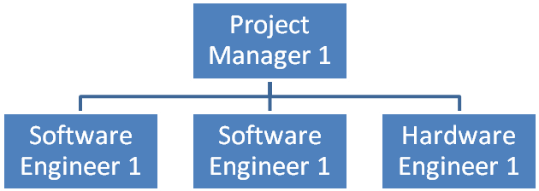
Diagram 1: Organizational Breakdown Structure

Personnel
Antonio G. Rodríguez-Jiménez
Antonio G. Rodríguez-Jiménez is a Computer Engineer from the University of Puerto Rico, Mayagüez Campus. He has taken courses related to Software and Hardware Engineering. He has experience with C, C++, Java, SQL and various Assembly languages. He has worked with Database Systems and Web Technologies, such as JDBC, JSP and Java Servlets. Also, he has worked in development of embedded systems based on the TI MSP430 microcontroller. During his studies, he worked in various undergraduate research projects such as Computer Graphics and WIMS. As part of the BMS project, he will be working in the Software Team, specifically the Database System and Web Application. He also will be giving support in hardware.
Arnaldo A. Oliver-Román
Arnaldo A. Oliver-Román is a Computer Engineer from the University of Puerto Rico at Mayagüez. Having specialized in Hardware, he has worked in several projects which include a Car Monitoring System and a Voltage Graphing Application, both of them involving TI microcontrollers. He also has worked with different data structures. He is skilled developing in Assembly, C/C++ and Java programming languages. His knowledge in the languages mentioned above and the experience working with hardware makes him a Hardware Engineer of the team.
Raúl Y. Mora-Colón
Raúl Y. Mora-Colón is a Computer Engineer specialized in Software. He has an excellent background working as a Webmaster, where he applies his knowledge in HTML, CSS, JavaScript, and as a Graphic Designer. He is skilled developing in various programming languages like C/C++, Java, and Assembly. The passion with his studies arrives to his hobbies, in which in his spare time he works in his own projects, like an online card game for the Windows Live Messenger®. He is also interested in Hardware, where he has developed experience thanks to the Microprocessor Interfacing course. His background in the software area qualifies him to be in the Software Team of this project.
Emanuel González-González
Emanuel González-González is a Computer Engineer specialized in Software. He also has a certification in Project Management. His experience includes design of companies’ software and system requirement specifications templates and programming languages including but not limited to SQL, C, XML and Java. He has also worked as Project Manager in projects like Hazardous Materials Online Teaching Tool for the University of Puerto Rico. His communication skills and leadership along with his experience qualifies him to be the Project Manager and Software Engineer of the team.
Consultants
- RFID module and system integration: Francisco J. Mendoza (Engineer)
- Database and web applications: Manuel Rodríguez (Professor)
- Microprocessor and hardware: José J. Rodriguez (Engineer)
- Library procedures and information: Jose L. Irizarry (Administrator)
- Along the span of life of the project, more consultants will be added as necessary.
Clients
- José F. Vega-Riveros
- Nayda G. Santiago-Santiago

Managerial Approaches
The will implement Scrum as the team development’s process model. The team will use the terms and monitoring way of the Scrum; each Sprint deadline will correspond to each Oral Exam deadline as presented in the Milestones section of this document. For being a part time project, instead of doing daily meetings to monitor the progress as Scrum guidelines recommend, the team will implement meetings three times per week, corresponding to Monday, Wednesday and Friday. These meetings can be changed as the managers considers necessary, with the consent of the team.

Special Skills
Skills required for the members of the team are good communication, team oriented, and writing skills. Also it is required programming languages skills including but not limited to HTML, Assembly, XML, C, Java (including web technologies), CSS, SQL. Experience with microprocessors and programming tools like Eclipse is necessary for the completion of this project.
It is established or recognized that not all the languages, tools and systems to be used for the development of this system are of knowledge to the team members. Therefore we are taking in consideration that team members will need to research and/or consult to obtain the necessary knowledge to fulfill their tasks for the completion of the project.

Specifications

Hardware Specifications
Hardware components
- Microcontroller
The selected microcontroller in BMS is the MSP430F149 from Texas Instruments®. The selection of this microcontroller is because the team has knowledge and experience working with it. Other reasons are that it is low power consumption, and it has two USART modules.
- RFID Tags
The RFID tags selected are passive. The main reason for this is that they are more economic tags than the active ones. Other reasons are that they don’t need power supply, and they are smaller. The selected tags are high frequency tags, its frequency is 13.56 MHz.
- RFID Module
The SkyeModule ™ M1 RFID Module made by SkyeTek ® was selected. The team chose this device because the module is a passive type, it is a multi-protocol reader, provides high –performance, it is a low power module, and it has four interface options: RS-232 or TTL/ serial, I2C, and SPI.
- RFID Antenna
The Feig 13.56 MHz external antenna made by Texas Instrument® was selected. The SkyeModule ™ M1 is not sufficient to fulfill the BMS range requirements, but this one have a reading range of up to 30 cm, which meets requirements. Also, since it is a pad-antenna, it is perfectly suitable for desk applications.
- USB – Serial UART Development Module
A USB – Serial UART Development Module will be used. This module has entire USB protocol handled on the chip that means: -No USB-specific firmware programming will be required. The main reason for selecting this is that it is cost-effective; the cost of the constructed module is less than the incurred costs in designing and developing the module by the team. Another reason is that it makes the systems easy to connect to the computer station.

Block Diagram

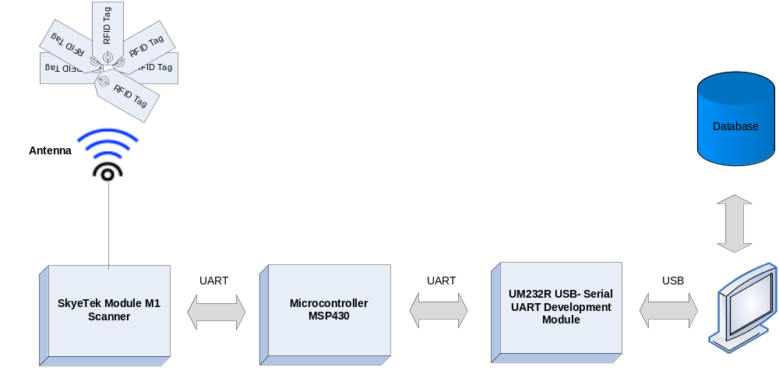Diagram 2: Block Diagram of the system

- Microcontroller
The microcontroller makes the interface between the RFID module and the computer station. It functions are: send commands to the RFID module, receive the ID read by the module, and send that data to the computer station in order to do all the corresponding process.
- RFID Tag
The tag has the ID of the item that would be scanned. This ID would be read by the RFID module.
- RFID Module
The functions of the RFID module are: read the RFID tags, and send the ID to the microcontroller in order to continue the process.
- RFID Antenna
The main function of the antenna is to add more reading range to the RFID module. This range is up to 30 cm (1 feet).
- USB – Serial UART Development Module
The main function of the UART development module is making the connection between the computer station and the microcontroller, in order to send and receive data between them.

Hardware Flowcharts
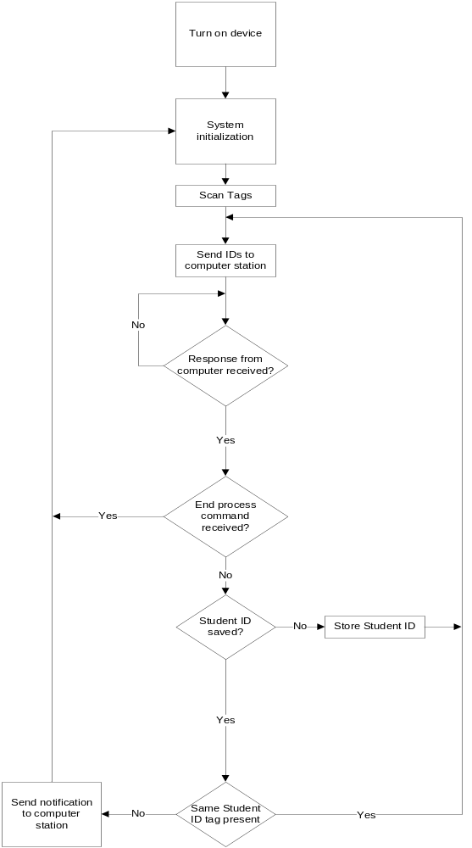
Diagram 3: Flowchart for book check-out
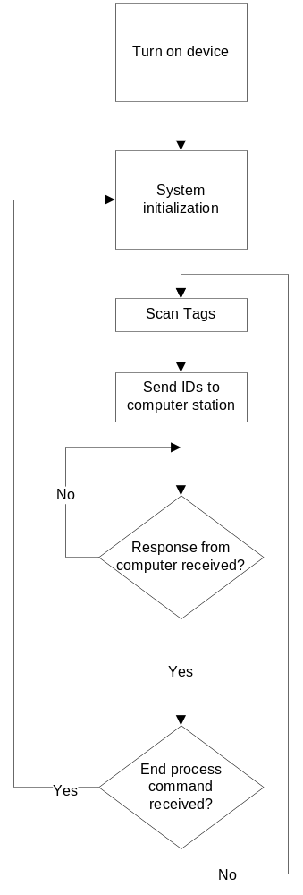
Diagram 4: Flow chart for book check-in

Software Specifications
    - Remote access functionalities
The Book Management System will have a web application. The main purpose of this application is to manage all books, employees, and costumers. It is compounded of three types of user; administrator, employee, and costumer. Each one has different functionalities displayed in its main webpage.
- Administrator
  - Manage Books
    - Add Books: Each time a new book arrives, the administrator has to use this function to add the book to the system. It is required to fill certain the book attributes.
    - Modify Book: This function permits to change any attribute of a book, if the administrator placed an erroneous data.
    - Remove Book: With this function the administrator will have the power of remove a book record, if the book is obsolete or for any other reason.
  - Manage customers
    - Add / remove costumer: Customers’ accounts can be created, or deleted by the administrator.
    - Modify info: With this function the administrator can change personal and transactional (leasing, bills and reservations) information of the customer.
  - Manage employees
    - Add / remove employee: Employees’ accounts can be created, or deleted by the administrator.
    - Modify Info: With this function the administrator can change personal information and different access or authorizations of the employee.
- Employee:
  - Manage customers: The employee will manage customers in the same way that the administrator will do it.
  - Change password: The employee can change its password. Its account will not have personal information, except the name.
- Costumer:
  - Edit Profile: The customer will have a profile in which it is permitted change the password and e-mail. If the customer wants to change other information, it has to contact the administrator.
  - Borrowed Books: In this section, the costumer can see the list of the books that has borrowed with its corresponding delivery date.
    - Renew: The delivery date can be renewed, if it has not concluded, or someone has not reserved the book.
  - Reserve Books: With this function the user can reserves any book. When the book is available, the user will be notified by e-mail.
  - Report Lost ID: The customer can report the ID, and the system automatically deactivates it.
    - Stations functionalities
The purpose of this application is simply to borrow and deliver books with a user-friendly interface. There are two types of station: Check-Out and Check-In.
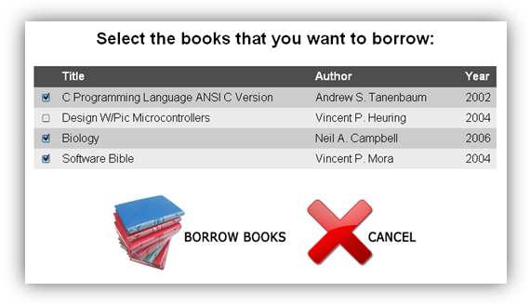
Diagram 5: Example of the books list of check-out station interface

- Check-Out: The station to borrow books will have the following four steps:
  - Welcome: This is main page that will be appears when the customer arrives at the station. It will have the instructions about how the customer has to insert the ID on the system.
  - Log-In: When the user places the ID on the scanner, the screen will show the user’s name. It will also show a message to letting know to the user that the system is ready for scan the books.
  - Books list: At this moment, the screen will show a list of the books that the user has scanned.
  - Delivery date: This is the last screen that the user will see. It will have the borrowed books list, with its delivery date. Five seconds later, the screen will show again the Welcome page.
- Check-In: The station to deliver books will have the following two steps:
  - Welcome: The main page will have instructions about how the books have to be delivered.
  - Delivered books list: Each time the user delivers a book, the book’s title is shown in the screen as delivered.

Database System Design

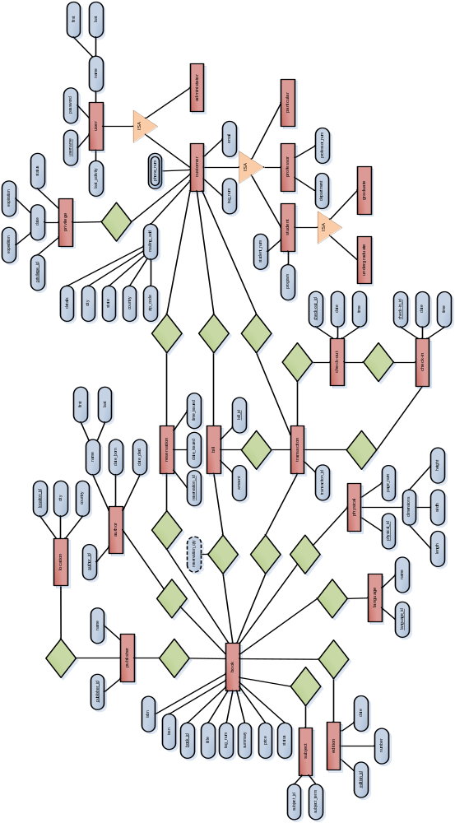
Diagram 6: Entity-Relation (ER) Diagram

Contractual aspects

Agreements with clients and third parties
A prototype of the system will be built with the functionality specified in this document. This product is not a final version, is a prototype. The prototype consists of a station where the users can checkout and check-in books, an administrator’s interface, a user’s interface and a book’s catalog search. The check-out and check-in systems will be implemented as one common station in the prototype for class purposes, because of team’s limited budget. Any modification should be reviewed and approved by the clients: José F. Vega-Riveros and Nayda G. Santiago-Santiago. For information of the proposed system and features, please refer to the Scope section of this document.

Milestones
Task | Due date
Project Proposal & Oral Presentation | September 10, 2008
Oral Exam 1 | October 15, 2008
Progress Report & Oral Presentation | October 29, 2008
Oral Exam 2 | November 5, 2008
Oral Exam 3 | November 26, 2008
Final Report | December 1, 2008
Final Project Presentation | Date selected by registrar’s office
Table 3: Project Milestones

Schedules

WBS

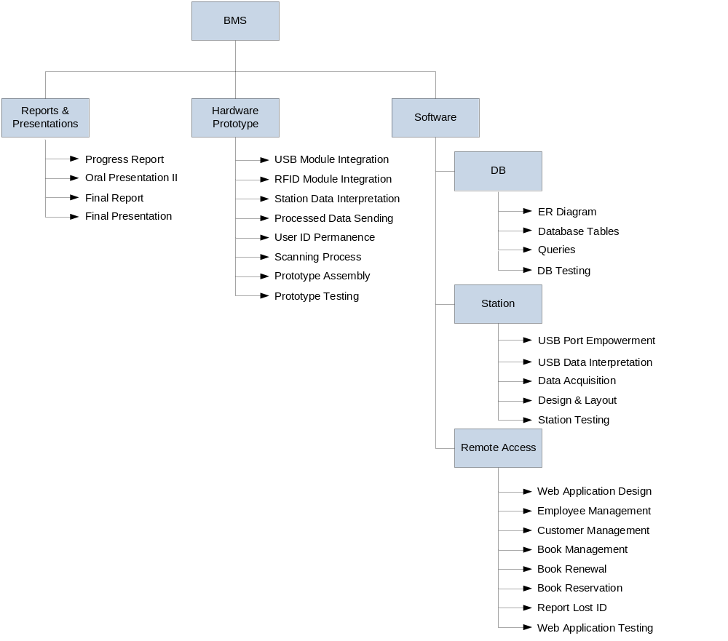Diagram 7: WBS Diagram

Outline of schedules (gannt chart)
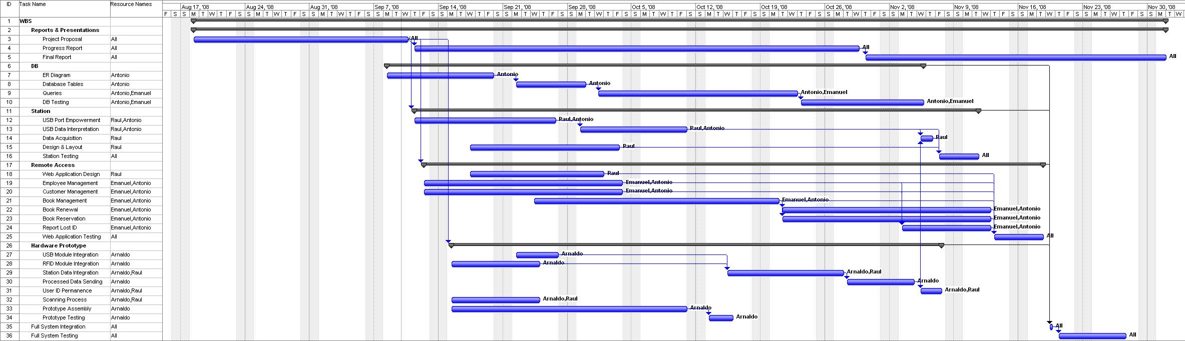

Resource requirements

Estimated project expenses
Human Resources | Salary per hour | Total hours | Amount
Software Engineer 1 | $25.24 | 240 | $6,057.60
Software Engineer 1 | $25.24 | 240 | $6,057.60
Hardware Engineer 1 | $25.07 | 240 | $6,016.80
Project Manager 1 | $46.20 | 250 | $11,550.00
Consultants (Professor / Administrator) | $125.00 | 20 | $2,500.00
Consultants (Engineer) | $50.00 | 20 | $1,000.00
 |  | Subtotal | $33,182.00
Equipment |  | Quantity | Amount
USB RS232 Module |  | 1 | $27.84
MSP 430 Development Kit |  | 1 | $171.18
SkyeTek M1 13.56 MHz Module |  | 1 | $125.00
RFID ANT PAD 320X240MM 13.56 MHZ |  | 1 | $237.80
Inventory Label Square Version (38x38)mm |  | 10 | $1.70
Thick Cards (Clamshell) |  | 5 | $1.64
Multimeter |  | 1 | $150.00
Power Supply |  | 1 | $40.00
Additional cables and connectors |  | - | $100.00
Emergency fund |  | - | $300.00
 |  | Subtotal | $1,177.02
Software |  | Quantity | Amount
MySQL® |  | 4 | $0
MySQL® GUI Tools |  | 4 | $0
Eclipse |  | 4 | $0
Apache™ Tomcat |  | 4 | $0
Exadel™ Studio |  | 4 | $0
Code Composer Essentials v3 |  | 4 | $0
SVN Tortoise |  | 4 | $0
 |  | Subtotal | $0
 |  | Direct Costs Subtotal | $34,359.02
Indirect & overhead costs |  | Qty. | Amount
Adobe® Photoshop® CS3 |  | 1 | -
Adobe® Dreamweaver® |  | 3 | -
Red Hat Developers Studio |  | 3 | -
IBM® Rational® Application Developer |  | 3 | -
Microsoft Project |  | 1 | -
Microsoft Visio |  | 4 | -
Computers |  | 4 | -
Utilities |  | - | -
Web server |  | 1 | -
Internet |  | - | -
Others |  | - | -
 |  | Subtotal | $20,271.82
 |  | Total | $54,630.84
Table 4: Project Budget

Human Resources
Employees’ salary is obtained from http://www.salary.com
Employees’ benefits include:
Bonuses 0.8%
Social Security 5.3%
Healthcare 8.8%
Disability 1.1%
Total benefits 16%
Total salary per hour is calculated using the equivalence of 1 year = 2080 hours

Software Engineer 1 basic salary per year: $45,271.00
Total benefits: $7243.36
Total salary per year: $52,514.36
Total salary per hour: $25.24

Hardware Engineer 1 basic salary per year: $44,954.00
Total benefits: $7,192.64
Total salary per year: $52,146.64
Total salary per hour: $25.07

Project Manager 1 basic salary per year: $74,652.00
Total benefits: $11,944.32
Total salary per year: $86,596.36
Total salary per hour: $41.63

Hardware Equipment
All hardware prices include the shipping & handling of the component if bought online. Emergency fund is created to manage any risk that materializes or to buy any additional equipment that is not currently taken into consideration, but can be necessary for project success in the implementation.
Software
For development of project in the course all software detailed in this section being use is free of charge, but for commercial purposes and product release some of these products require royalties to be presented or paid to them for the product release.
Indirect & overhead costs
Indirect costs are calculated based on 59% of the direct costs as specified in the Capstone presentation Preparing a Budget for a Project.
$34,359.02 X 59% = $20,271.82

Assessment methods

Assessment
Evaluation of the project as described in the course is presented below:
Demonstration 1 | 10%
Demonstration 2 | 10%
Final Demonstration | 20%
Proposal and oral presentation | 15%
Progress Report and oral presentation | 15%
Final Project Report and oral presentation | 20%
Attendance and punctuality | 5%
Discussion and participation | 5%
Total | 100%
Table 5: Project Assessment Procedures

Procedures for monitoring, collecting and storing data
Project’s code and parts of the system will be documented following the Java code conventions by ©Sun Microsystems. Also the work done will be submitted to a repository that will be available for the project. Each member must submit his work to the repository, and is responsible to have a backup of the data. Each week, meetings will be held for the manager to monitor the progress of the project, based on the tasks. These meetings can be changed as the Manager considers necessary for the best of the team. More details are available in the Managerial Approaches section.
For each task assigned to a member the format to evaluate its progress will be:
0% - no work related to this task has been done
25% - task has been started
50% - there is functionality or progress in the task
75% - task is done and in testing mode
100% - task completed

Quality Control
- Implementation
  - Java code conventions by ©Sun Microsystems will be used
- Revision
  - Code will be revised by a fellow member of the team other than its creator
- Testing
  - Unit - Each separate unit of the project will be tested to ensure operation.
  - Integrity - Integration of the components will be tested to ensure adequate interaction of parts.
  - System – Complete testing of the full system will be implemented to validate correct functioning of the system.
- Verification
  - Ensure that project complies with design specifications.
- Validation
  - Ensure that project complies with clients requisites.

Potential Problems

Risk assessment
Risk | Impact | Probability
Components unavailable | HIGH | LOW
Changes in requirements | HIGH | LOW
Computer failure | LOW | HIGH
Data lost or damaged | HIGH | LOW
Electrical problem | LOW | LOW
Hardware damaged | HIGH | LOW
Internet connection failure | LOW | LOW
Member resigned | HIGH | LOW
Natural phenomena | LOW | HIGH
Strike in university | LOW | LOW
Task undelivered by a team member | HIGH | LOW
Table 6: Risks Assessments

Risk plans
Following the Pareto principle, only twenty percent of the risks are materialized eighty percent of the time. Therefore we will explain the Risk Mitigation, Monitoring and Management plan for the risks with higher impact, but all the risks are taken in consideration.
- Components unavailable
If necessary components do not arrive on time, we will have to get the components available at local stores and contact the orders suppliers to get the components on time. To mitigate this risk all parts that were considered necessary were acquired or bought online at the beginning of the semester. The orders are currently being monitored to check the status or location of the components.
- Changes in requirements
If changes in requirements are requested from client, then those changes will be negotiated and applied as soon as possible to prevent the project from falling behind schedule and to implement those changes. The change in requirement will be analyzed to adjudicate its impact towards the project. As a precaution there will be constant communication with clients, to inform the status of the project; they will be informed of any changes that most be agreed to reduce its impact in the project.
- Data lost or damaged
If data is lost or damaged, then the data will be replaced with its backup. If no backup is available, then the project's schedule as last option can be modified, to include the necessary time to produce the equivalent data. This has to be approved by the Project Manager and has to be justified. There will be a repository or equivalent system to ensure the data and developers will retain a copy of their work. Also some data can be managed via email so multiple backups can be available if one of them is lost.
- Hardware damaged
If damage or failure of essential hardware occurs, then it will be repaired if possible and if time permits it. If it is not possible to repair the damaged hardware, then new hardware most be bought. The decision will also depend on the cost and availability of the hardware component. To prevent damage of hardware, data sheets, documentation and/or other information of the equipment must be used and members will follow all specifications and cautions necessary.
- Member lost
If a team member is lost during the semester for any reason, then the tasks assigned to that member will be reassigned to the other team members and the project schedule will be modified accordingly. If this risk is materialized the manager will inform and negotiate with clients, to minimize the project’s impact as possible. To mitigate this risk the manager of the team will be monitoring all members to see their progress to ensure the team is working efficiently and that there is communication among members.
- Tasks undelivered by a team member
If a team member does not delivers his assigned tasks by its respective deadline, and if the member knows in advance, the member must justify the delay, substitute the task with another task or the task can be reassigned to another member with the manager's authorization. This task will be evaluated to see if it can delay the project completion, to select the best approach to manage this risk. To be aware of any situation the progress of the members and their tasks are being monitored by the project manager, and tasks are assigned a delivery date.

Impacts

Environmental
Currently this project do not generates any new materials; it is using existing materials combined to make this product. The RFID tags used in this system lasts for more than twenty years. Since the RFID’s are passive they do not posses any battery or power and can remain in the book for its life, and its size is minimum. The station for user interaction is similar to a regular computer and can be disposed with the same implications of a regular computer. The other components to be in consideration are the microprocessor, antenna, RFID module and USB module. All these four parts, comply with the RoHS, and can be recycled. These aspects make this project one environmentally safe and/or with a minimum impact to the environment.

Legal
For the development tools and programs used in the implementation of BMS the following licenses must be considered: Eclipse Public License (EPL), GNU General Public License (GPL) (MySQL and TortoiseSVN), Apache License and Adobe Proprietary Licenses. After examination of the terms of usage of these tools and considering that the majority of these tools are available in UPRM for educational purposes, we conclude that the development of BMS fulfills the requirements of the terms of use of these products. For more information about the details of these licenses, please refer to the References section.
As for the terms of usage of the product, copyright and distribution rights, and possible extensions of the project, the users are bound to the following rules and terms:
- The copyright and distribution rights of all the material which is directly or indirectly related to this project are property of the Ants Team.
- Any license, permission of usage or any modification to the project should be requested to all team members: Emanuel Gonzalez-Gonzalez, Raúl Y. Mora-Colón, Arnaldo A. Oliver-Román and Antonio G. Rodríguez-Jiménez.
- All the requests will be evaluated and conceded if and only if all the members give their authorization.
- Each license of usage is made available for only one party. No redistribution of material is permitted.
Any extern party that wishes to issue a request is subject to these terms and rules; any violation to these terms will be referred to the pertinent authorities.

Social
People from the current society, like to be independent and also like to make things simpler and faster, especially students. This system attacks those problems when visiting a library to borrow a book. Since users of the system do not depend on any person to borrow a book, this system also has the option to scan several books at the same time; expectations are that customers waste less time in carrying out this process. Therefore, the customer does not have to wait to be served by a librarian and at the same time the process will consume less time, having thus extra time for additional tasks, or simply get a pleasant experience. The system does not intend to replace librarians; it helps them make a part of their work faster.

Market overview
Libraries with the desire to have a more efficient, reliable and a faster system are BMS’ potential consumers. The product provides a faster experience to libraries' customers. Faster due to the RFID technology that provides a better book scanning. The user can process multiple books at the same time, and do not have to look for a sensor within the book. The equipment used in this system last longer than barcodes, which is the commonly used technology. Therefore, libraries that are looking for any of these advantages can be attracted to this product.
BMS’ direct competitor in both Puerto Rico and United States is 3M™ and in United States only is Checkpoint®. 3M™ offers a product for libraries, and Checkpoint® has a focus in inventory management. Now both companies have made an agreement as Checkpoint® states: “a new partnership makes 3M™ the exclusive worldwide reseller of and customer service provider for Checkpoint’s line of library security and productivity products.”
Direct comparison
Book Monitoring System | 3M™ & Checkpoint® partnership
Check-in station | Check-in station
Check-out station | Check-out station
Book renewal and reservation | Shelf scanner to organize books
Comparing the system of BMS with the 3M™ & Checkpoint® partnership, both systems provide for check-out and check-in of books which are similar features. In contrast, 3M™ & Checkpoint® partnership provides a shelf scanner to organize books, while BMS intends to provides a web application for the customer to manage his/her account and make the book renewal and reservation process.

References
- Amal Graafstra. RFID Toys. Indiana: Wiley, 2004.
- Henry, Sudarshan , and Abraham Silberschatz. Database System Concepts. McGraw-Hill, 2005.
- “RFID Vs Barcodes: What’s The Smarter Option?” Jun. 21, 2006. India Business Week. Aug. 22, 2008 <http://indiabusinessweek.com/Opinion/Editorial/RFID.html>.
- Boss, Richard. “RFID Technology.” May 14, 2004. Public Library Association. Aug. 23, 2008 <http://www.ala.org/ala/pla/plapubs/technotes/rfidtechnology.cfm>.
- “Salary.com.” 2008. Sep. 1, 2008 <http://www.salary.com>.
- “American Barcode and RFID.” 2007. Aug. 21, 2008 <http://www.abrfid.com/rfid/articles/passive-active-tags.aspx>.

http://en.wikipedia.org/wiki/Scrum_(development)
http://www.eclipse.org/
http://en.wikipedia.org/wiki/Pareto_principle
http://en.wikipedia.org/wiki/Restriction_of_Hazardous_Substances_Directive
http://solutions.3m.com/wps/portal/3M/en_US/library/home/
http://checkpointsystems.com/default.aspx?page=librarysecurity

